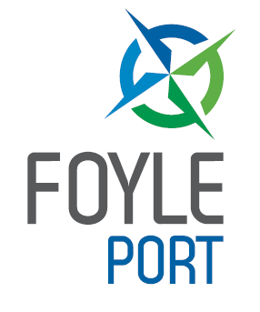

LONDONDERRY PORT

WASTE MANAGEMENT PLAN

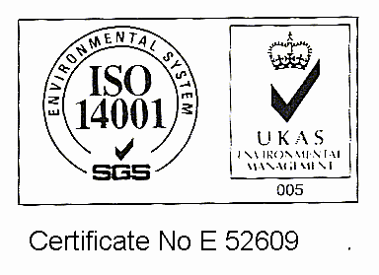

Contents

1 Introduction

2 Waste Information Leaflet

3 Procedure for the Collection of Waste

4 Private Terminals, Pontoon and Ships at Anchor

5 Contingency for Changing Circumstance

6 Reporting Inadequacies

7 Consultation

8 Legislation

9 Failure to Comply

10 Contacts

11 Amendments

12 Distribution List

Appendix 1 – Map of Terminals at Londonderry Port

Appendix 2 – Annex C from MCA Port Waste Management

Appendix 3 – Example Waste Notification Form

Appendix 4 – Amendment History

1. Introduction

The UK Government is committed to reducing the impact of shipping on the environment. The key piece of legislation providing a framework on regulating pollution from ships is The International Convention on the Prevention of Pollution from Ships known as MARPOL 73/78.

The UK uses various Merchant Shipping regulations to implement MARPOL requirements. European Union [EU] Directive 2000/59/EC on port reception facilities for ship generated waste and cargo residues require all member states to provide the legal framework to adhere to these regulations. The UK has achieved this through the creation of The Merchant Shipping and Fishing Vessels (Port Waste Reception Facilities Regulations) 2003.

MARPOL 73/78 requires member states to ensure that facilities are adequate and do not cause undue delay to ships. Under the regulations this rule applies to all ships other than fishing vessels and recreational craft authorised to carry no more than 12 passengers. They must notify in advance of arriving in Port the details of the waste onboard to be discharged.

Responsibility:
The Harbour Master holds responsibility for the implementation of this Waste Management Plan.

Notification
Notification should be made in advance by fax or e-mail to ships agents. If a vessel does not use a ships agent, then notification should be made by fax or e-mail through to Port Operations. Agents are requested to forward these notification forms to Port Operations.

Contact Us Harbour Office: 028 71 860555
Port Operations: 028 71 865756
Harbour Radio: 02871 860313
E-mail: info@londonderryport.com

2. Waste Information Leaflet

The following waste information leaflet is made available to all vessels.

Please retain on board

INFORMATION ABOUT WASTE CONTROL

General Map

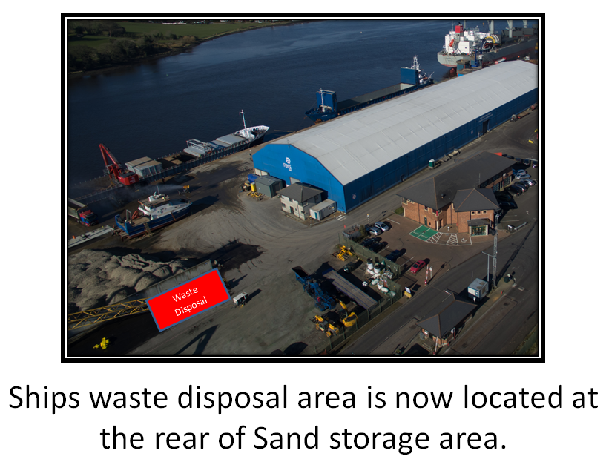

General Map

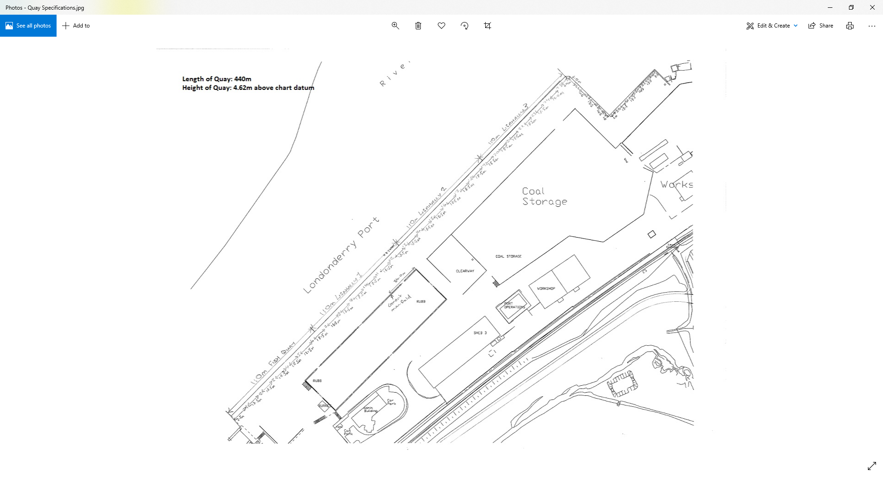

Waste Information Leaflet Continued

WASTE CONTROL

Galley Waste & Non-Galley Waste
Garbage must be segregated into Galley Waste & Non-Galley Waste. Two Garbage Skips; one for Galley Waste and one for Non-Galley Waste are located outside Port Operations. Garbage can only be landed between the hours of 8 am and 4 pm.

Galley Waste
Galley Waste refers to waste of animal origin and from products of animal origin. This includes meat, milk, cheese, animal fats, fish, honey and any other product made with a product of animal origin, or derived from one (such as gelatine) EU Directive 1774/2002

Galley Waste must be placed into the locked Red skip. A key may be obtained at either Port Operations or Harbour Radio. The key must be signed for upon issue and upon return.

Non-Galley Waste
This includes packaging, banding, paper and plastics. Oily rags, filters, batteries and paint tins MUST NOT be put in skips but segregated and landed separately. Notify your agent or the terminal operator if you wish to discharge these.

Scrap Metal
A separate skip is available outside Port Operations for the disposal of scrap metal.

Waste Wood / Dunnage
Should a vessel wish to discharge waste wood/dunnage; the ship’s agent should contact Port Operations to arrange for its collection.

Dirty Ballast Water/Bilge Water/Sewage Sludge
These are discharged by road tanker. Contact your ships agent for details.

Waste Information Leaflet Continued

Charges
A levy of £0.06 is charged per gross registered tonne. This covers the disposal of Galley and Non-Galley waste. The disposal of other waste material is charged separately.

Notice
In order to negotiate the most cost efficient and expedient facilities for you, it would be helpful if you could give 24 hours notice of your requirements to your agent, and at least 2 hours notice to the Port of Londonderry Harbour Office.

Grievances
If you find any deficiency in the system or feel that excessive charges have been levied, please contact the Harbour Master.

This leaflet issued by: Londonderry Port
Port Road, Lisahally
Londonderry
Northern Ireland BT47 6FL

Telephone: 028 71865756 (Port Operations) 71860313 (24 hr)

Fax: 028 71861656 VHF: Channel 14

3. Procedure for the Collection of Waste

Ships Master

Notification form
Details of ships waste to be landed and waste to be stored on board

Ships Agent
No Ships Agent Notification of waste to be landed direct from ship to Port Operations

Notification forms to be forwarded to Port Operations by ships agent.
Ship’s crew land waste

LPHC Port Operations

Port Waste Reception Facility
Series of skips adjacent to the Harbour Office.

Annual return to be submitted to MCA – see Appendix 2

MCA

Procedure
Prior notification should be made by ships master to the ship’s agent. Notification forms should be forwarded by ships agents to Port Operations.

Ships Masters should direct crew to waste reception facility on main quay and waste should be placed in the correct skips provided.

The Waste Reception Facility will be monitored to ensure correct use.

Waste will be regularly removed by licensed waste carriers and appropriate Transfer documents retained.

Waste Oils
Waste oils and oily bilge water shall be removed by road tanker with prior notification organised through ships agents or directly with waste disposal contractors.

Sewage
Sewage shall be removed by road tanker with prior notification organised through ships agents or directly with waste disposal contractors.

Hazardous Waste
Hazardous wastes are subject to the requirements of the EC’s Hazardous Waste Directive (91/689/EEC). The Directive is currently transposed in Northern Ireland by the Special Waste Regulations (Northern Ireland) 1998. These wastes include materials with explosive, flammable, oxidising, irritant, harmful, toxic, carcinogenic and corrosive properties.

Any vessel wishing to discharge hazardous waste should contact Port Operations via their agent and appropriate arrangements will be made.

Records
Records of all wastes landed shall be maintained by Londonderry Port.

4. Private Terminals, Pontoon and Ships at Anchor

Private Terminals
There are three private Terminals in operation within the Port Authority.

Coolkeeragh ESB Maydown
LSS/Invista Maydown
Topaz Londonderry

These independent terminals provide waste reception facilities on the jetties and vessels will be charged directly through the terminal operators.

Notification will still be required through ships agents.

Pontoon
LPHC operates a pontoon facility at Queens Quay in the city centre for visiting yachts and local leisure craft. Provision is made for the removal of this waste by Londonderry Port.

Ships at Anchor
Ships at anchor will not be charged for waste disposal.
Port Waste Reception legislation is not applicable to Fishing vessels.

5. Contingency for Changing Circumstance

Should circumstances change, provision will be made to meet any new waste facility requirements.

6. Reporting inadequacies of Port Waste Reception Facilities

If any ships master has found our Port Waste Reception Facilities to be inadequate, please fax the following form to your agent and /or Port Operations.

Name of Ship:

Name of Ships Agent:

IMO number:

Gross Tonnage:

Port of Registry:

Type of ship:
Bulk Carrier Oil tanker Cargo Ship

Chemical Tanker Ferry Cruise ship

Other (specify)

Nature of Complaint:

Masters Name:

Signature Date:

Londonderry Port shall endeavour to resolve this complaint to your satisfaction.
If this is not possible please complete the MCA form relating to PWR Inadequacies

7. Consultation

Londonderry Port shall consult with ships agents, marine port users, waste contractors and terminal operators through the usual communication channels of telephone, e-mail, letters and meetings. The Harbour Master who holds responsibility for this waste management plan is in daily contact with interested parties. Waste management issues are audited and reviewed within the Ports ISO 14001 Environmental Management System.

8. Legislation

The International Convention on the Prevention of Pollution from Ships known as MARPOL 73/78. MARPOL 73/78 requires member states to ensure that facilities are adequate and do not cause undue delay to ships.

European Union [EU] Directive 2000/59/EC on port reception facilities for ship generated waste and cargo residues. This directive is implemented in the UK through the ‘The Merchant Shipping and Fishing Vessels (Port Waste Reception Facilities Regulations) (SI 2003 / No. 1809)’

EC’s Hazardous Waste Directive (91/689/EEC). The Directive is currently transposed in Northern Ireland by the Special Waste Regulations (Northern Ireland) 1998.

Animal Health By-products Regulations (EC/1774/2002)

Guidance for Ports and further information can be viewed on the MCA Website www.mcga.gov.uk

9. Failure to Comply

Vessels that fail to comply with the Port Waste Management Plan will be reported to the MCA.

10. Contacts

Londonderry Port and Harbour Commissioners contact details.

Port Operations Tel: 028 71 865756
Fax: 028 71 861656
E- mail: info@londonderry–port.co.uk

Harbour Master Tel: 028 71 861113
E-mail: bill.mccann@foyleport.com Fax: 028 71 861656

Berthing Master Tel: 028 71 865773
E-mail: kevin.okane@foyleport.com Fax: 028 71 861656

Main Harbour office Tel: 028 71 860555
Fax: 028 71 861168

Skip Hire / Dunnage River Ridge Recycling
Tel: 028 70 868844
Fax: 028 71 347788

Waste Oil / Dirty Ballast or Bilge Water Enva
Tel: 028 97 561574
Fax: 028 97 561576

Waste Oil / Dirty Ballast or Bilge Water Irish Waste
Tel: 028 90810000
Fax: 028 90810001

Sewage Sludge Precision Clean
Tel: 028 71 860135
Fax: 028 71 860942

11. Amendments

The Waste Management Plan is a Code of Practice controlled under the integrated management system which has been externally certified to the following standards.
- ISO 14001 Environmental Management
- ISO 9001 Quality management
- ISO 45001 Occupational health & Safety Management

Amendments to the plan will be recorded through the integrated management systems.

12. Distribution List

Regulators:

MCA Bangor David Polley
E-mail: david.polley@mcga.gov.uk
Tel: 020381 72012

Derry City Council Paul McSwiggan

Environment and Heritage Service Kerry Anderson

Port Users:
- Stevedores
- Shipping Agents
- FPI
- Balcas
- IAWS

Berth Operators:

- Coolkeeragh ESB
- Invista
- LSS

Appendix 1 – Map of Terminals at Londonderry Port

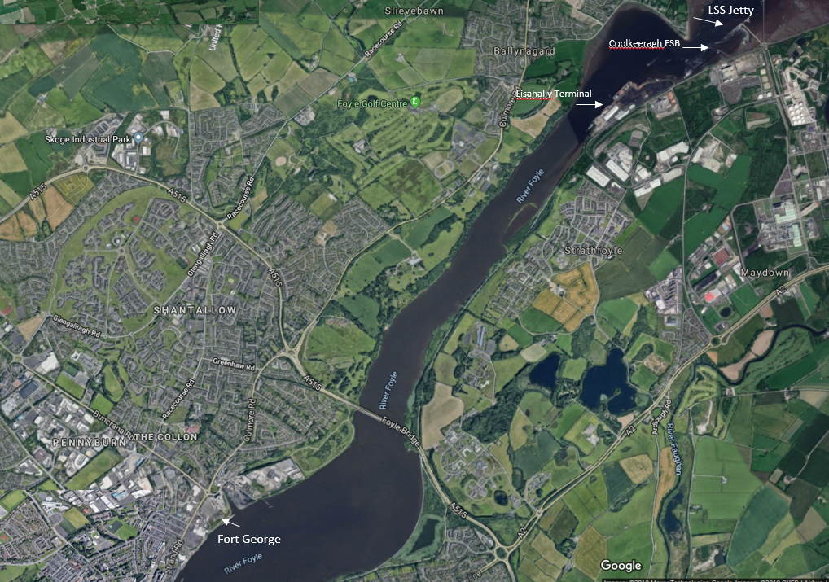

Lisahally Terminal/Foyle Port
Fort George (Cruise Terminal)
LSS Jetty
Coolkeeragh ESB

Appendix 2 – Annex C from MCA Waste Management Planning, A Guide to Good Practice

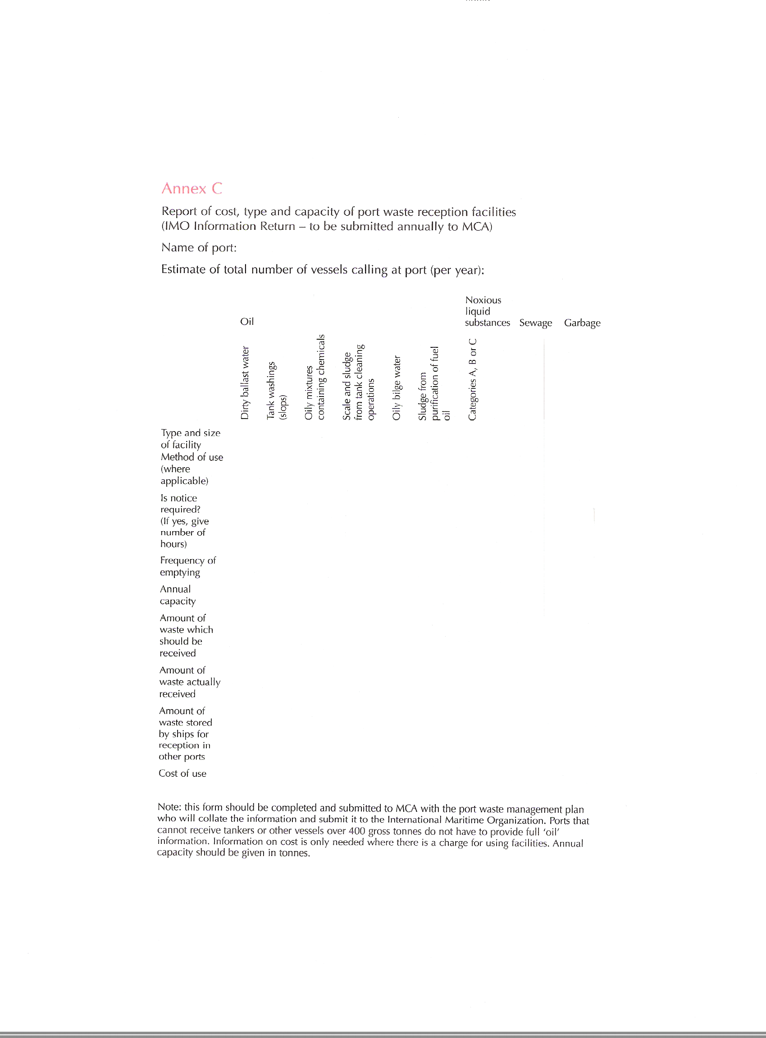

Planning,
A Guide To Good Practice (April 2004)

Appendix 3 – Example Waste Notification Form

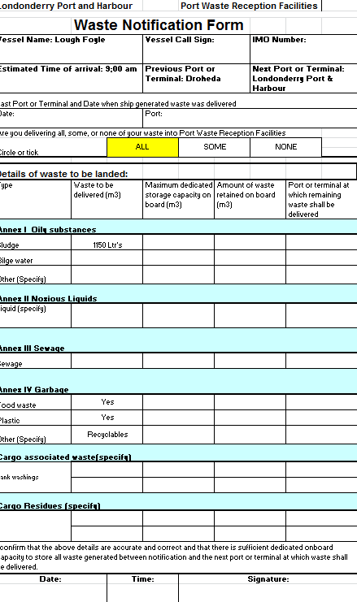

Appendix – 4 Amendment History

AMENDMENT HISTORY

Revision | Description of change | Author | Release Date
2014 Rev 2 | 11, Amendments. The standards have been defined within this section.  Appendix-4, an amendment history section has been added to the plan | Damien Rodgers | January 2014
2018 Rev 3 | Page 10. Email address updated for harbour Master  Berthing Master contact details added | Damien Rodgers | April 2018
2018 Rev 4 | MCA phone details updated for Dave Polley. MCA Audit completed 21st Sept | Damien  Rodgers | September 2018
2018 Rev 5 | Waste disposal area relocated | Damien  Rodgers | November 2018
2018 Rev 5 | Waste disposal map added to improve communication for visiting ships. | Damien  Rodgers | October 2019

